**Title:**

* The Prairie Squirrel
* Go Go Squirrel
* Squirrel Sprint
* Squirrel on a Mission

**Functionality:**

* [topdown tutorial](https://youtu.be/Luf2Kr5s3BM?si=tXbBr-Ta6B_ujb1r)
* [Pick and throw object](https://www.youtube.com/watch?v=D4mVVx4njno&t=820s)
* [How to use git with Godot](https://docs.godotengine.org/en/stable/tutorials/best_practices/version_control_systems.html#:~:text=Using%20Git%20from%20inside%20the,be%20found%20on%20its%20wiki.)
* [More on how to Git & Godot](https://www.youtube.com/watch?v=Y1kHRc9OfN0) (Watch this by the meeting on 01/24!)
* [A good reference for what we want for our game](https://www.youtube.com/watch?v=S8lMTwSRoRg) → Start watching it a lot of useful things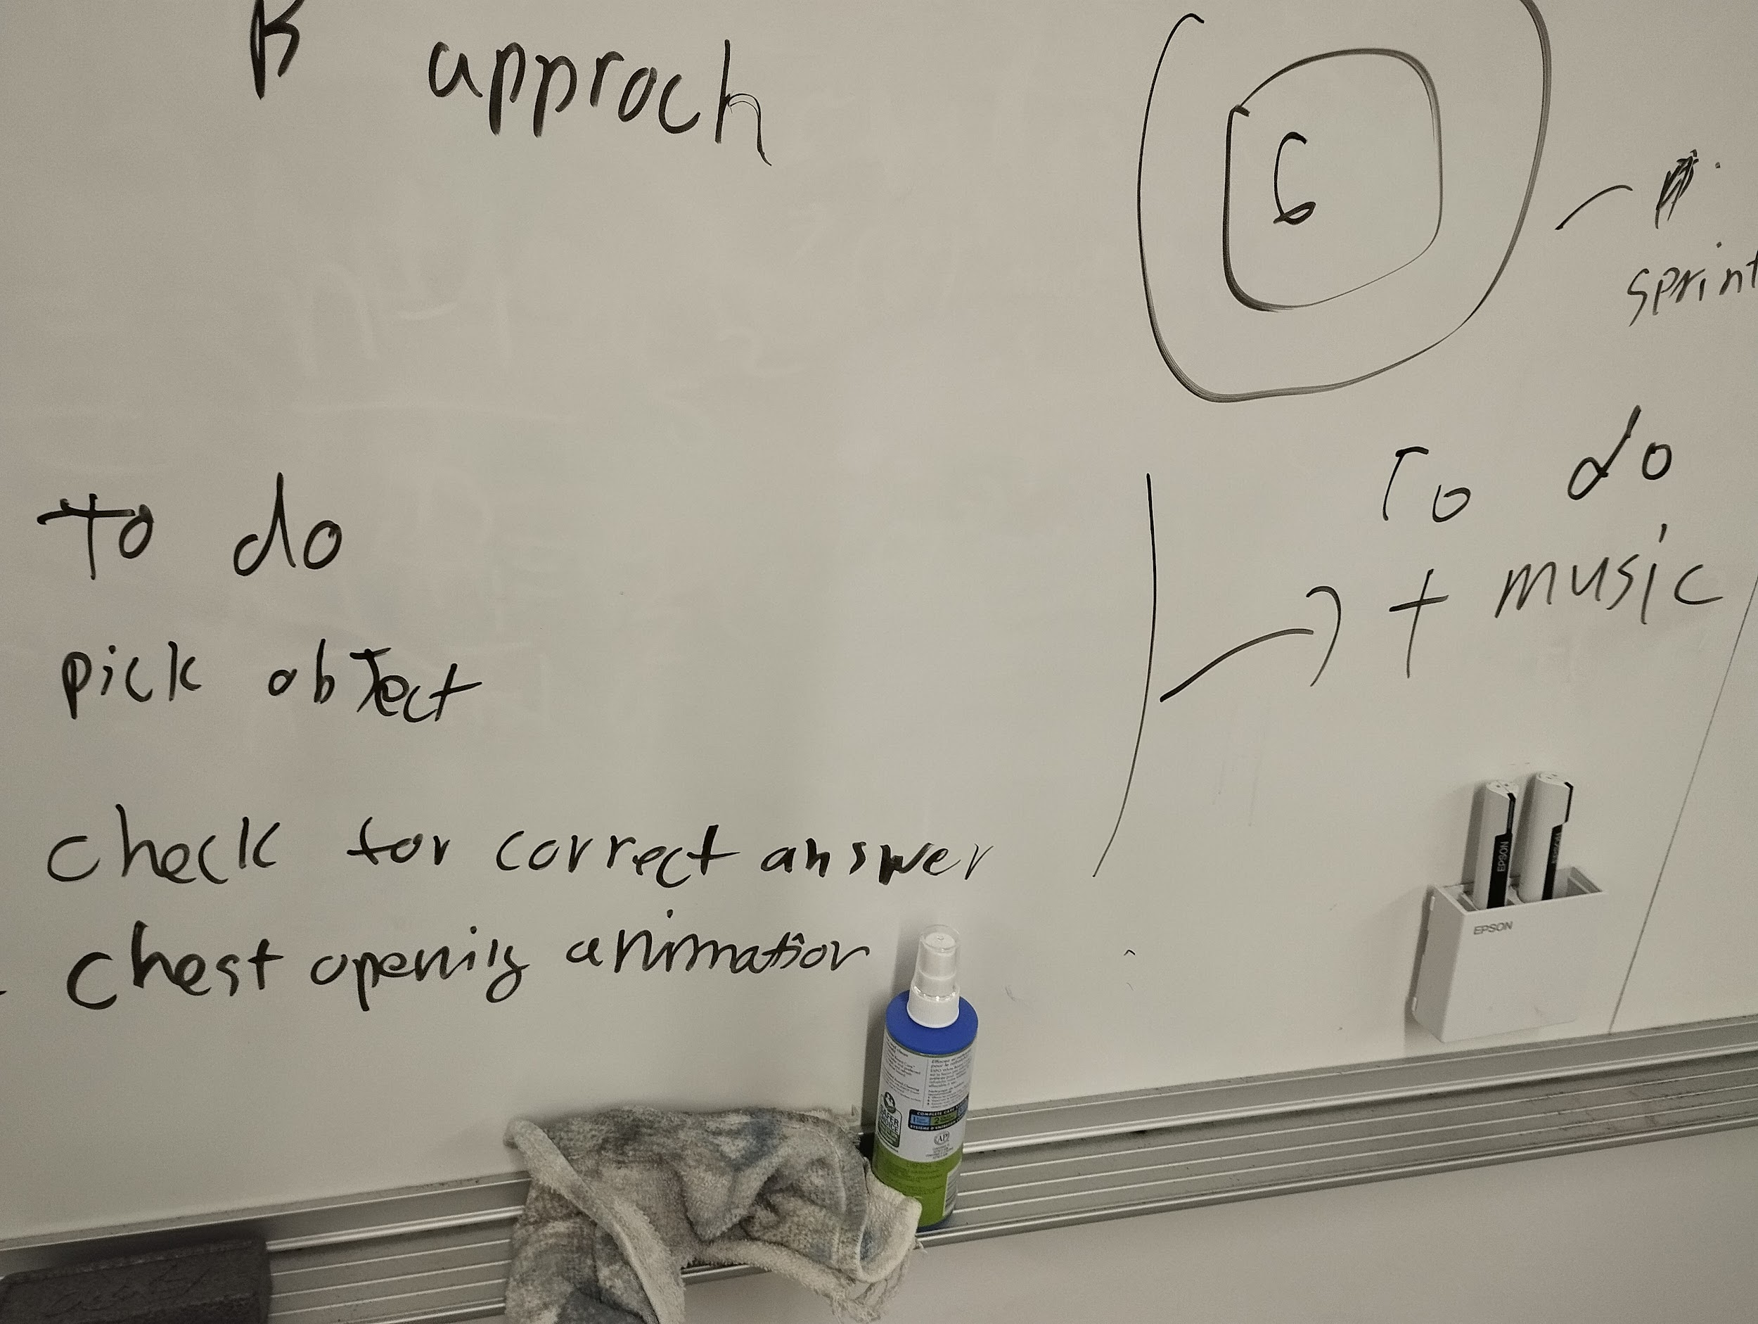

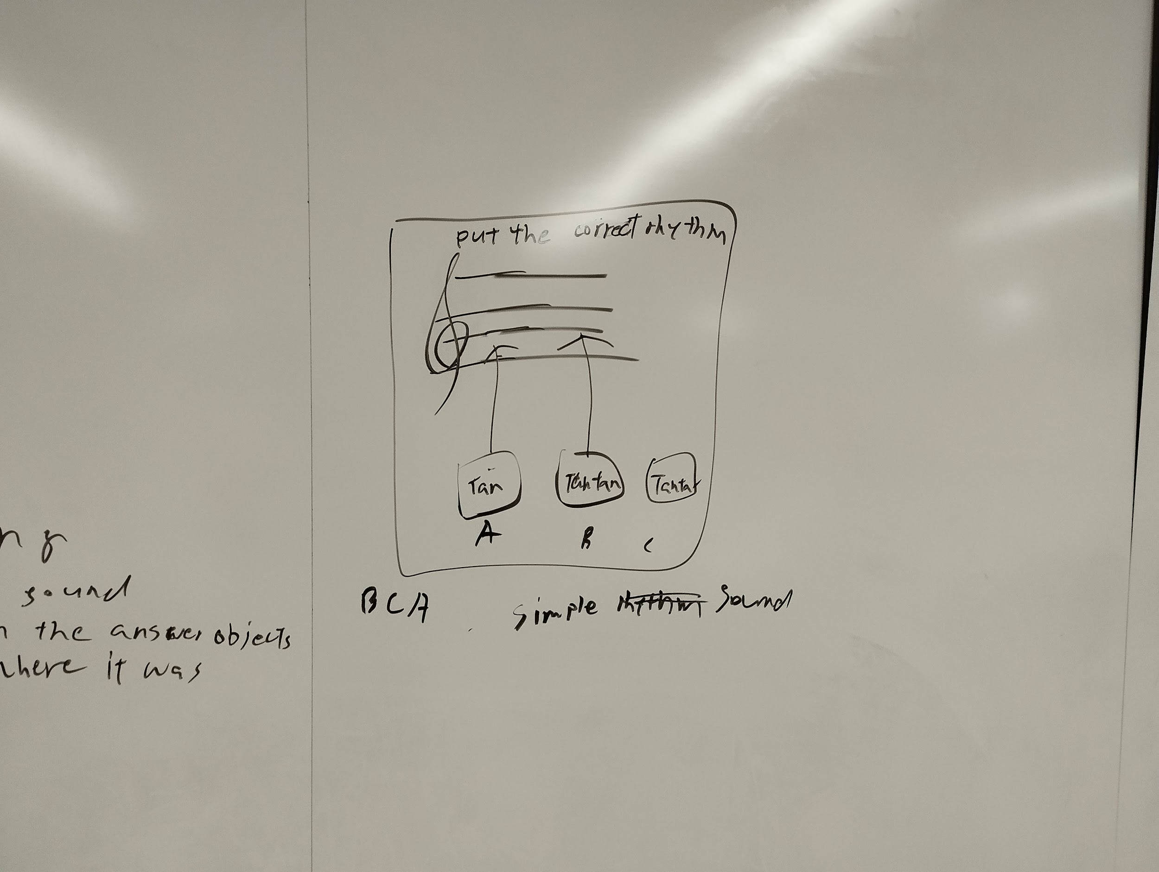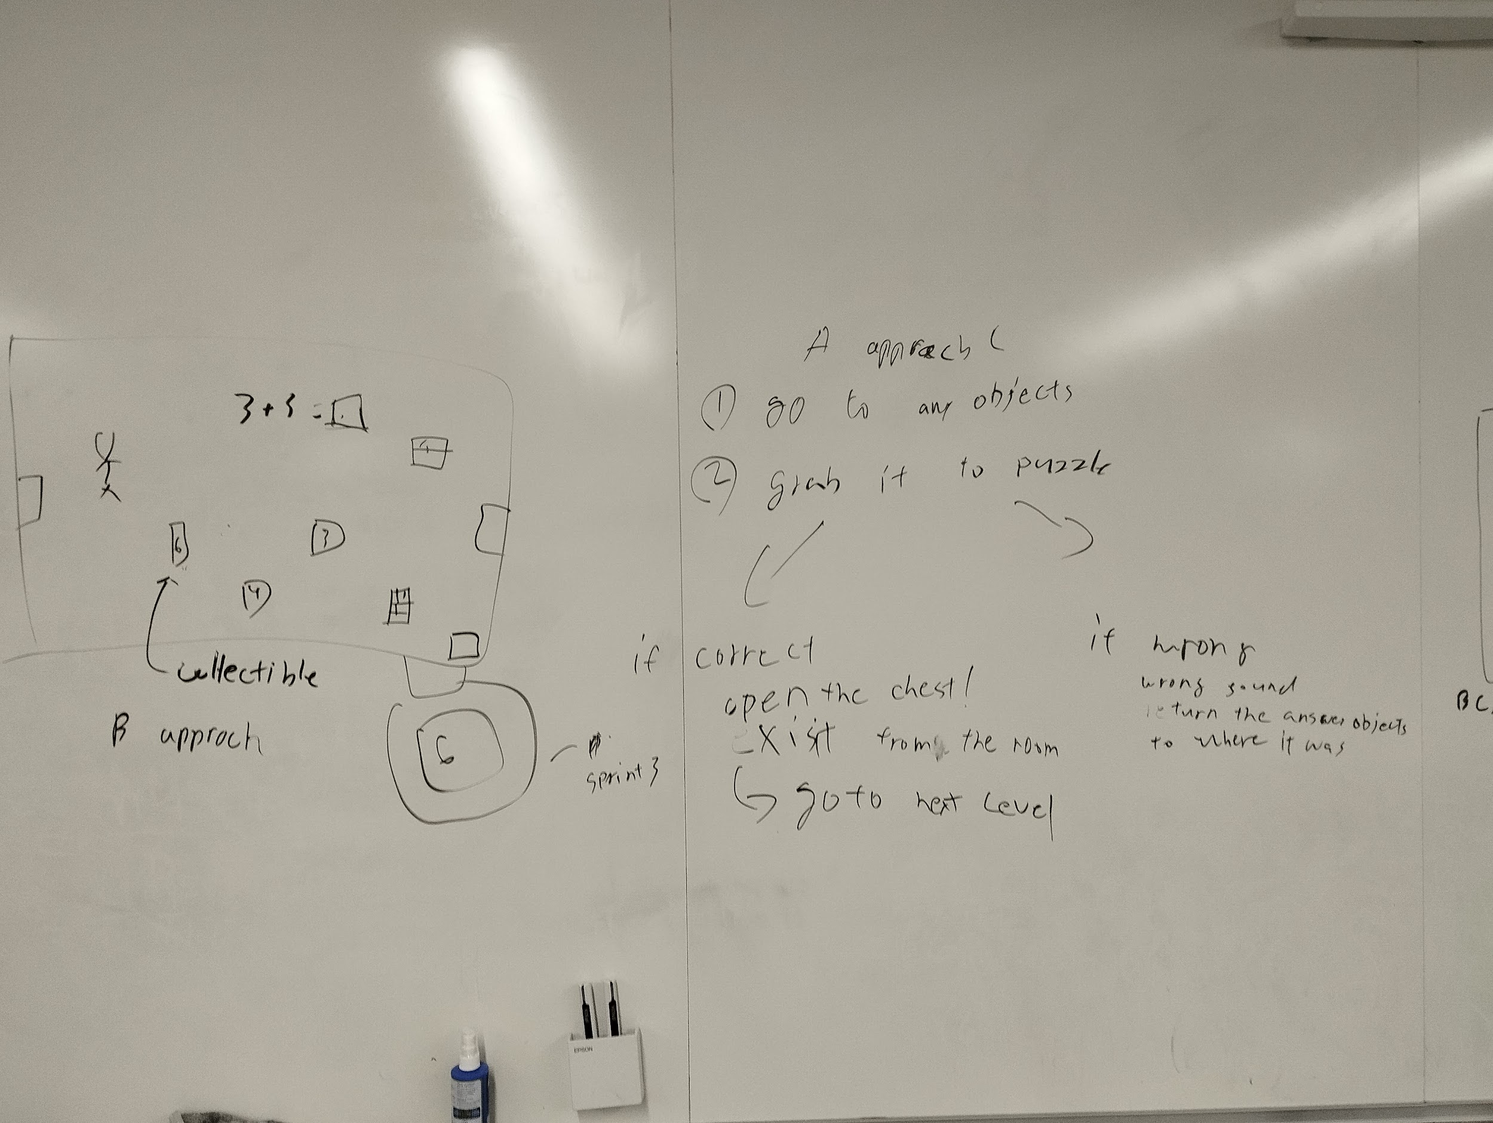

**Aesthetics:**

* Night time squirrel sprint
* Pixelated things

**Assets:**

* 8-bit things relating to squirrel and squirrel life
* [800mb-asset list](https://kenney.nl/data/itch/preview/)
* Buildings - <https://www.youtube.com/watch?v=TWE7CqfD6_M> (**Pixelate photos)**
  + <https://kamisama887.itch.io/lorenz-fries-school-horror>
  + <https://img8bit.com/>(I used this website to create 8-bit version of the building)
  + <https://catowo.itch.io/school-tile-set-japanese-style-dark-wood-rpg-maker-mv>
  + <https://ansimuz.itch.io/sunny-land-pixel-game-art>

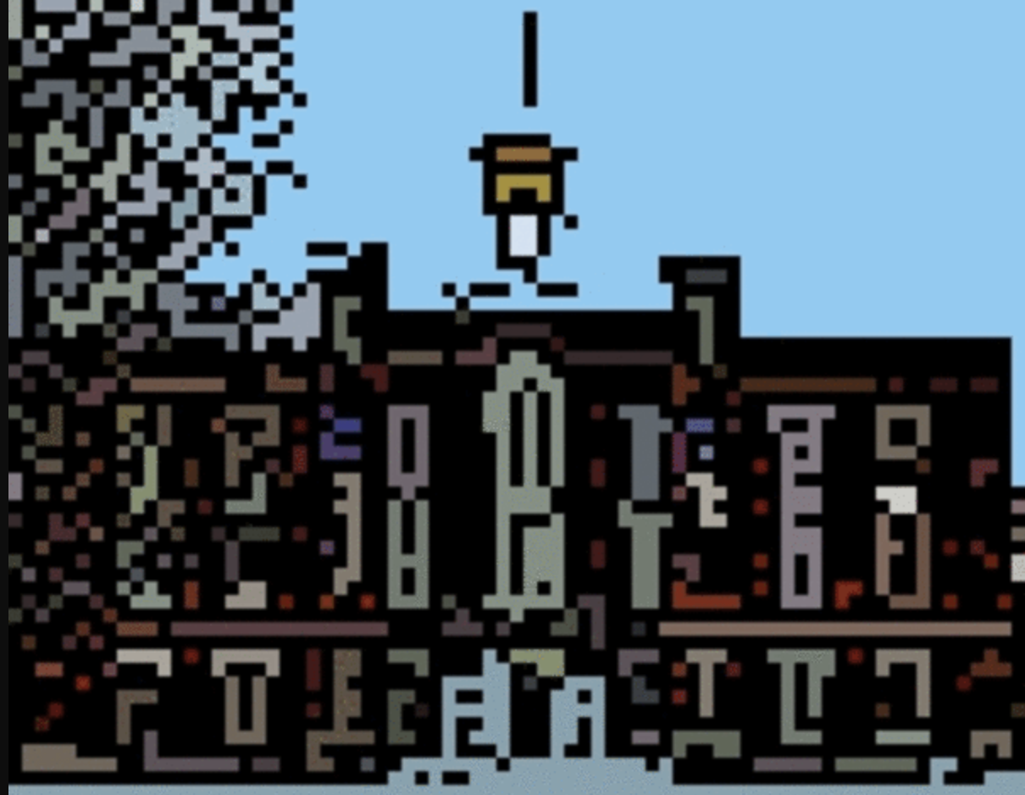

* Squirrel
* Health
* Acorn
  + [Pixel art acorn by CaptainStack (itch.io)](https://captainstack.itch.io/pixel-art-acorn) (free)
  + <https://www.shutterstock.com/image-vector/acorn-pixel-art-icon-isolated-on-1426272467>
* Bushes/ trees
* Top-down asset ideas
  + <https://krishna-palacio.itch.io/minifantasy-towns-ii>
* Nature things
  + <https://alpatyk.itch.io/free-asset-farmer-story-sprites-and-backgrounds>
  + <https://free-game-assets.itch.io/free-green-zone-tileset-pixel-art>
* Fox and Humans
  + Fox : [2D Pixel Art Fox Sprites by Elthen's Pixel Art Shop (itch.io)](https://elthen.itch.io/2d-pixel-art-fox-sprites)
* sign post
  + <https://gx310.itch.io/sign-posts>

**Features:**

* Health element
* Extra life
* Background and foreground movements → squirrel runs faster than the background
* Obstacles → bushes and things
  + Students and Foxes

**Levels:**

* Get an acorn at completion of level
* Puzzle at the end or at particular locations of the map layout
* <https://www.youtube.com/watch?v=XHbrKdsZrxY> - level tutorial

**Goal/s** (what defines winning)**:**

* Winter is coming so collect acorns for the hibernation period

**How the game works:**

* Avoid students
* Collect health
* Little platform bushes/trees it climbs and stuff on the way to its destination
* Enemies:
  + 2 options either attack them or avoid them
  + Attacking costs health but you get power like speedup for 30 seconds
* Distance from one building to the other → a minute or 1.5
* Number of acorn also denotes the level you are on
  + If you die or fail a level you start from the previous level

**Puzzle/Quiz:**

* Based on the theme of the building/location squirrel gets to
* SMC/CFA?
* Health will give you multiple attempts to solve the puzzle

**Flowchart:**

* Title Screen:
  + Start button
  + Credits
  + Controls
  + Simple background of nature landscape
* Stage 1 (Tutorial/storyline)
  + Start from alumni hall
    - Meet other squirrels who will in conversation tell you the storyline, motive and rules of the game
  + This is the “tutorial” section
  + It will have the health and acorn bar on the top left corner
* Level 1 - part 1:
  + Runner starts and jump through obstacles → trees, bushes, rocks, walls
  + Objective: Collect health
  + Avoid or attack enemy:
    - Follows rules mentioned above
* Level 1 - part 2:
  + Get to SMAC → puzzle 1
  + Solve puzzle and get an acorn
    - Give acorn to friend, it will be like the friend is the acorn basket
* Level 2 - part 1:
  + Similar as level
  + New building to get to → CFA
* Level 2 - part 2:
  + Collect the music notes

**Sounds:**

* music - <https://artlist.io/royalty-free-music?utm_source=google&utm_medium=cpc&utm_campaign=18940250865&utm_content=141461267017&utm_term=royalty%20free%20music&keyword=royalty%20free%20music&ad=637217231429&matchtype=e&device=c&gad_source=1&gclid=Cj0KCQiAwbitBhDIARIsABfFYIJSKcAdZLMOm04XRBxnrPHjBU7cZ_VwL8aWCO-06-GN0iTaKRn6ySQaAj3tEALw_wcB>
* Sound effects - <https://www.epidemicsound.com/sound-effects/?_us=adwords&_usx=17283189012_sound%20effects%20free&utm_source=google&utm_medium=paidsearch&utm_campaign=17283189012&utm_term=sound%20effects%20free&gclid=Cj0KCQiAwbitBhDIARIsABfFYIICo4ZjyUP2flHMHgmFNLqyCRxqHlFZ3YteHxxAWwcq82QEVYp4zRsaAot-EALw_wcB>
* Squirrel squeak?
  + <https://www.youtube.com/watch?v=2RJyumO8bYc>

## 

## **Sprint Goals!!!**

**Prototype 1:**

* Basic functionality
  + Side scrolling
  + Background and foreground movement
  + What keys will have the functions required?
* Game Layout →
  + Map (alumni to Smac, Smac to CFA)
  + Obstacles
  + Puzzles

**Prototype 2:**

* Introduce health element
* Introduce enemies
* Adding music background

**Prototype 3:**

* Adding power ups
* Adding sound effects

Flag video: <https://www.youtube.com/watch?v=GZrALMvOwY8&t=286s>

color changing: [**https://www.youtube.com/watch?v=0_ZI-Sz-s_I**](https://www.youtube.com/watch?v=0_ZI-Sz-s_I)

move data between scenes: <https://www.youtube.com/watch?v=N4iV1L6xb04>

Squirrel motivation - looking for food for the winter

NPC - Other squirrel looking for acorns

* how’s your collection of acorns going
* I’m just coming from _
* fox game me a lot of trouble

Collision layers:

1 - background

2 - player

3 - objects

4 - enemy

moving npc: <https://www.youtube.com/watch?v=LMSbPkNgnWA&t=832s>

**FEEDBACK for Sprint2**

What is actionable?

-fixing the bugs

-implementing enemies

-controlling buttons(space to pick up and drop objects)

-putting the instruction more neat(such as signs)

What was unexpected?

-The game worked for most of the people’s computer

-bugs on SMC

What do you have to ignore?

-no double jump because that would require re-designing of the stages

-assets because we think they are consistent